Python Commands
% finds the remainder or as a string input (
%d specifier is used to insert integers only into a string,
%f and %s format specifiers can be used to insert floats and strings respectively.

Match: case: matches value/string to predetermined variable/case
\n : prints whatever follows on a new line
\t : adds a space then prints whatever follows
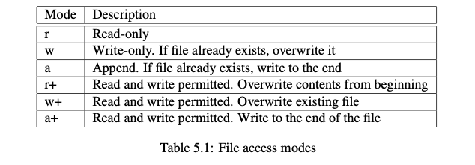
the ord() function returns the integer mapping of each character

Append function adds to the end of a list
.insert adds to a list in specific areas with indexed parameter
.pop deletes last item to a list or indexed variable deletes specific part in a list
.sort alphabetically orders the list

